1. Trade Reference List :

URI : localhost:8080/trade-mgmt/v1/trade-refs

Method Type : GET

Response :

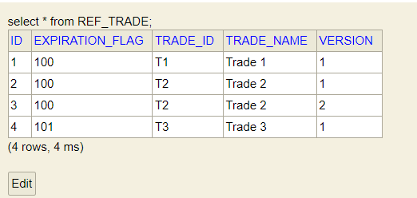

[

    {

        "seqId": 1,

        "tradeId": "T1",

        "tradeName": "Trade 1",

        "version": 1,

        "expired": **false**,

        "expirationFlag": 100

    },

    {

        "seqId": 2,

        "tradeId": "T2",

        "tradeName": "Trade 2",

        "version": 1,

        "expired": **false**,

        "expirationFlag": 100

    },

    {

        "seqId": 3,

        "tradeId": "T2",

        "tradeName": "Trade 2",

        "version": 2,

        "expired": **false**,

        "expirationFlag": 100

    },

    {

        "seqId": 4,

        "tradeId": "T3",

        "tradeName": "Trade 3",

        "version": 1,

        "expired": **true**,

        "expirationFlag": 101

    }

]

1. Initiate Trade Transition:

URI : localhost:8080/trade-mgmt/v1/initiate-trade

Method Type : POST

Request :

{

        "tradeId": "T2",

        "version": 2,

        "cpId": "CP-1",

        "bookingId": "B1",

        "lockingPeriod": 2

}

Response :

{

    "seqId": 1,

    "tradeSeqId": 3,

    "cpId": "CP-1",

    "bookingId": "B1",

    "creationDate": "2023-01-30T18:21:58.089+00:00",

    "maturityDate": "2025-01-30T18:21:58.089+00:00"

}

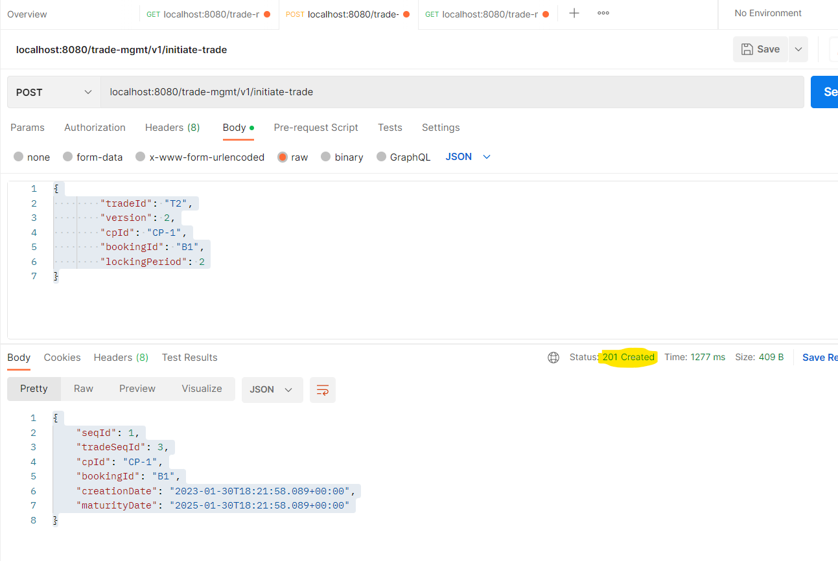

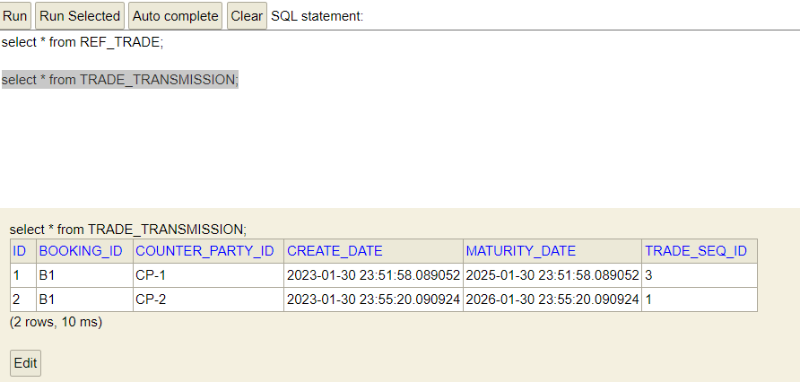

1. Initiate Trade Transition with Lower version and get Error validation response:

URI : localhost:8080/trade-mgmt/v1/initiate-trade

Method Type : POST

Request :

{

        "tradeId": "T2",

        "version": 1,

        "cpId": "CP-1",

        "bookingId": "B1",

        "lockingPeriod": 2

}

Response :

{

    "timeStamp": "2023-01-30T18:27:47.474+00:00",

    "message": "Transmission can not be processed as the Lower Version Trade (i.e : 1 ) has been received",

    "details": "uri=/trade-mgmt/v1/initiate-trade"

}

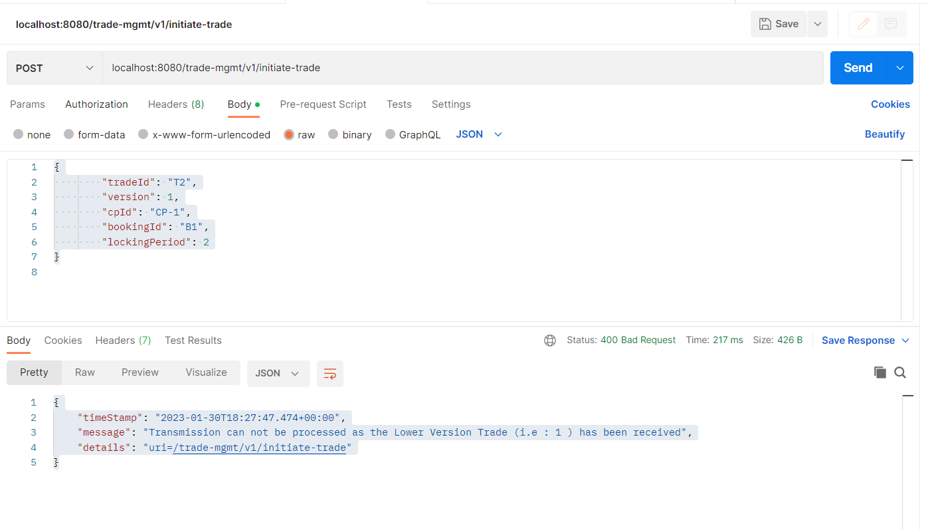

1. Initiate Trade Transition with Maturity Date less than today’s date:

URI : localhost:8080/trade-mgmt/v1/initiate-trade

Method Type : POST

Request :

{

        "tradeId": "T1",

        "version": 1,

        "cpId": "CP-1",

        "bookingId": "B1",

        "lockingPeriod": -2

}

Response :

{

    "timeStamp": "2023-01-30T18:31:07.056+00:00",

    "message": "Transmission can not be processed as Maturity Date  is (i.e : Sun Jan 31 00:01:07 IST 2021 ) is less than today's date",

    "details": "uri=/trade-mgmt/v1/initiate-trade"

}

